2.4-2.7: Hybrid Session 1

Prefer to complete this activity offline? - download the following documents:

* Full PowerPoint slides: [Hybrid Session 1 Full Slides.pptx](https://winchester.instructure.com/files/1666498/download?wrap=1)
* Walkthroughs:
  + [2.4 Creating Variables in Python Walkthrough.docx](https://winchester.instructure.com/files/1666499/download?wrap=1)
  + [2.6 Lists Walkthrough.docx](https://winchester.instructure.com/files/1666501/download?wrap=1)
* Worksheets:
  + [2.5 Assignment and Operators Worksheet.docx](https://winchester.instructure.com/files/1666502/download?wrap=1)
  + [2.7 List Operations Worksheet.docx](https://winchester.instructure.com/files/1666505/download?wrap=1)

In this topic, we will be focussing on the following learning outcome for this week:

* Outline and implement different types of variables within programming
* Implement programs which make use of lists within Python

You will have the following learning opportunities:

* To create and use variables within Python
* To discuss code quality with a particular focus on PEP
* To understand, create, and use lists within Python

During this online session, you will be engaging in acquisition, discussion, investigation, practice and production learning activities.

# Welcome to Session

For this session we will be focussing on the following topics:

* Variables;
* Data Types Recap;
* Creating Variables in Python;
* Assignment and Operators; and
* Lists

# 2.4: Variables

One of the mechanisms for storing and using data is through the use of variables.  In this section of the session, we will be looking at what variables are, building on the different types which were discussed within the pre-session materials, and finally demonstrating how variables are implemented within Python.

In this part of the first hybrid session, we introduced the concept of variables and revisited PEP and data types (which were covered in the pre-session materials).  We also completed an example of how to create and use variables in Python.

# 2.5: Assignment and Operators

In this section, we will be discussing the variety of different ways in which variables can be operated on.  These operations are essentially actions which can occur when using variables.  We will also discuss assignment shortcuts as part of the activities within this element.

During this part of the session, you were provided with a worksheet to introduce you to the different operators which are available within Python.

We also talked about Floating Point numbers and the accuracy associated with them. The following video gives a really accessible explanation of why floats introduce rounding errors.

<https://youtu.be/PZRI1IfStY0>

[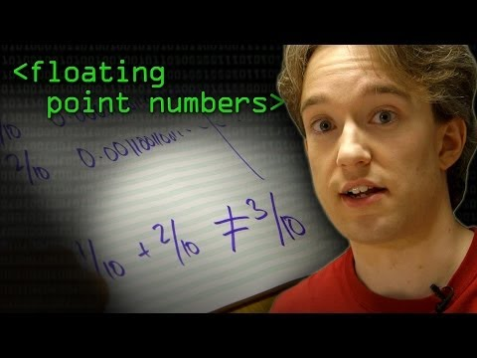](https://www.youtube.com/embed/PZRI1IfStY0?feature=oembed)

# 2.6: Lists

Lists are a particular type of variable which holds multiple values.  This allows us to operate on them as a whole collection or on individual elements.  The key element of this is that that list must contain related data, we don't just create lists with random data.  In this part of the session, we will talk about what lists are and also how we define them within Python.

In the hybrid session, we looked at defining what a list is, creating a list in Python, and accessing both the list as a whole and individual elements.

# 2.7: List Operations

There are a number of different possible operations which can be used on lists.  In this section, we will investigate the different operations which are possible and examine their outputs.

The final part of the first session involved running through a worksheet which identified a number of different operations which could be carried out on a list.  You needed to run the code and highlight what the output was.